Date | 04 October 2026
Team ID | SWTID-2026-4732
Project Name | Implement Client Script & UI Policy (Incident)
Team Leader | Karuppa Sami Kasi Visvanathan S
Team member | Bala M
Team member | Saifur Rahuman Z
Team member | Karthik T
Maximum mark | 5

Controlling Urgency: Configuring a UI Policy Action for High

Impact Incidents

The project is based on improving the Incident Management process by ensuring that important fields are properly controlled when an Incident has a high impact. In the existing process, users may enter Incident information manually, which can result in incomplete or inconsistent data. This can affect incident triage, routing, reporting accuracy, and service quality.

The idea was developed to introduce a UI Policy that automatically applies specific controls whenever the Impact of an Incident is set to High. The UI Policy provides a standardized

way to enforce business rules directly on the Incident form.

The project user story is: As an Incident Management user, I want additional field controls to be automatically applied when an Incident has High Impact so that important Incident information is entered consistently and accurately.

The proposed solution uses a ServiceNow UI Policy named “High Impact Control” on the Incident table. When the Impact field is set to 1 – High, the policy triggers the required field behavior. The Assignment group is configured as mandatory, and the Reverse if false option ensures that the changes are reverted when the condition is no longer satisfied.

This approach reduces manual checking, improves data consistency, and helps ensure that high-impact Incidents follow the defined business rules.

Screenshot:

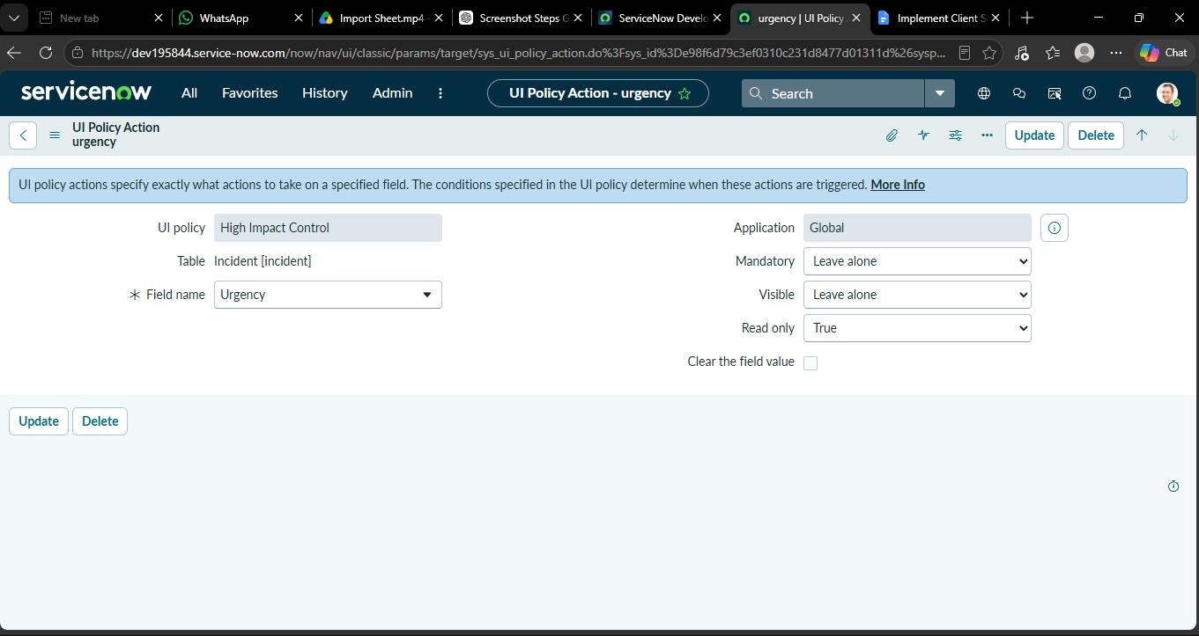

UI Policy Action Flow :

| Problem: Manual entry causing incomplete or inconsistent data |

|

V

| Need: Automatically apply specific controls when Impact is High |

|

V

| Solution: Configure a UI Policy Action under "High Impact Control" |

|

V

| Target Field: Urgency |

|

V

| Action Applied: Read only set to True |

|

V

| Result: Reduced manual checking and improved data consistency |

